Holidays on Mars.
Warm up
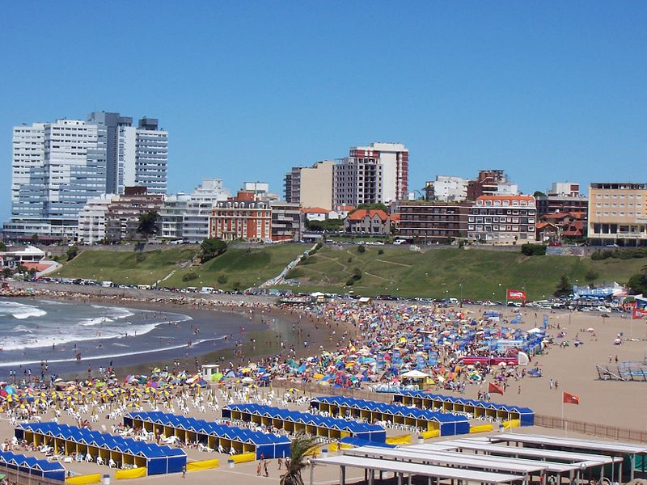 | 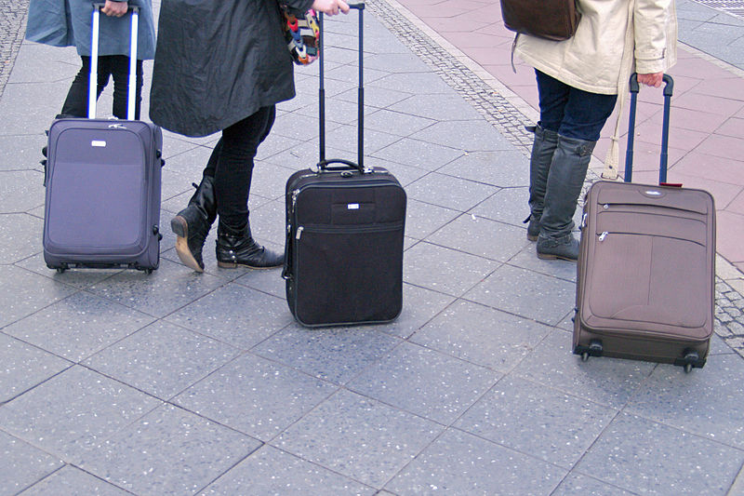 | 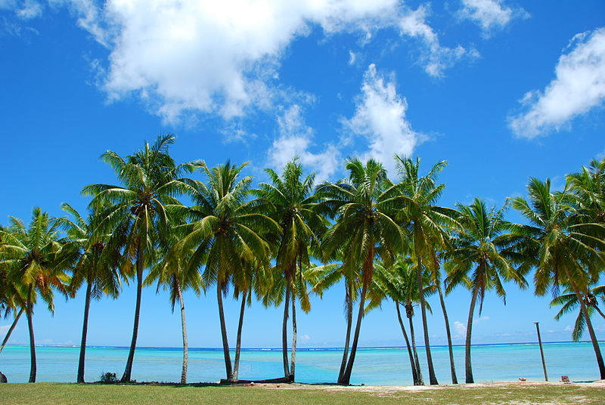
- Think about the vocabulary area of holidays – you have two minutes to brainstorm as many words as you can related to holidays with your partner – go!

Now compare with your class – add any new vocabulary to your list.

- Look at the pictures below. Which place would you prefer to go on holiday to? Why?
Tell your partner/group.

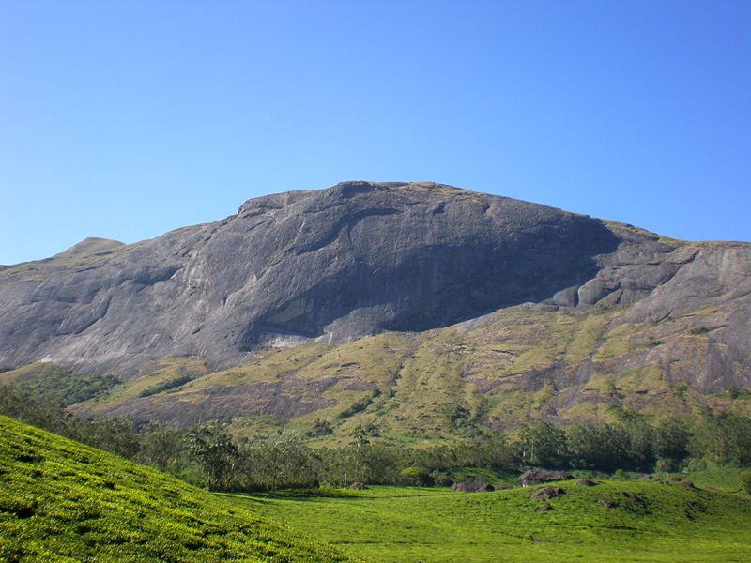 | 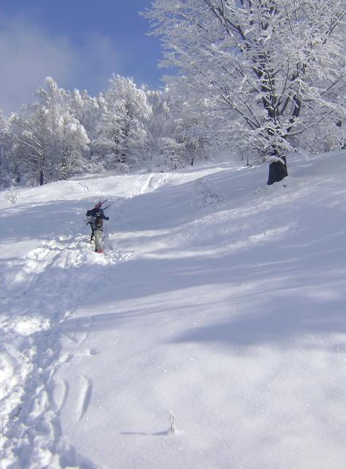 | 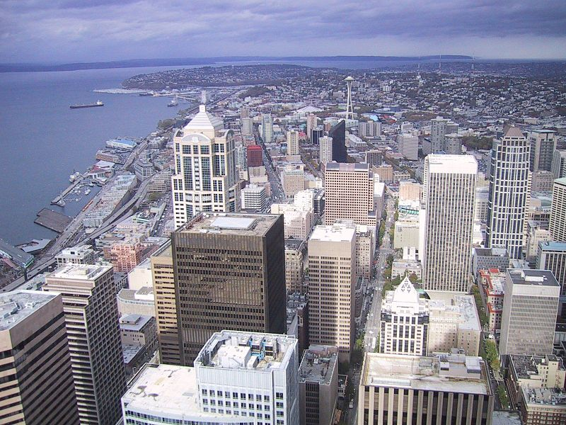 | 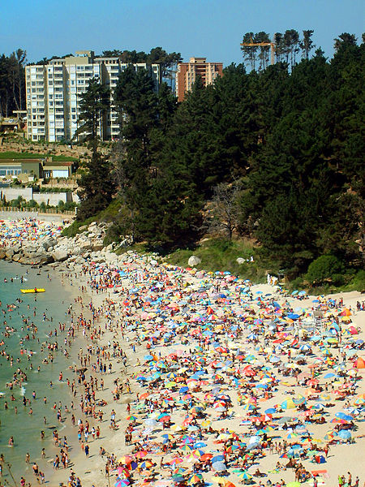
- Now discuss your answers to the questions below in groups. Don’t forget to say why you feel a particular way about something.

- What was your favourite holiday? Why? Where did you go? Where did you stay? Who did you stay with?
- What is your favourite type of holiday? Why?
- What type of holiday do you not enjoy? Why not?
- If you could go on holiday anywhere in the world where would you choose? Why? Who would you take with you?
- Would you like to go on holiday in space? Why/why not?
- Do you think holidays in space will be possible in the future? What might be the advantages and disadvantages of this?
Vocabulary

- Match the vocabulary in the box with the correct meaning below.
tourism chalet camping sightseeing
cruise journey travel vacation

- ________________: Another word meaning holiday.

- ________________: A holiday where you stay on a boat and travel around stopping at different places.

- ________________: A noun meaning the commercial organisation of holidays.

- ________________: A verb meaning to make a journey/ go from one place to another.

- ________________: A wooden house with a large sloping roof, typically found in the mountains e.g. the Swiss Alps.

- ______________: A verb which describes the activity of visiting places of interest in a particular city/location.

- _____________: The activity of spending a holiday staying in a tent.

- _____________: The noun to describe the time that you spend travelling from one place to another.

- Complete the sentences with the correct verb.
pack board hitchhike check in
take off book land

- John will be here soon – his plane _________ in 30 minutes.
- I’ve got all my clothes ready, now I just need to ____________my suitcase.
- It’s not a good idea to ___________; if you get in a car with a stranger you never know what might happen!
- We can only ___________to the hotel at 2pm so there is no point in arriving before then.
- Would you like to __________a tour to the volcano? It looks amazing!
- Hurry up! Our plane is going to ___________in ten minutes and we don’t want to be late!
- I really hate being on a plane for _____________, it makes my ears pop!

Reading
- Read the article below quickly. Turn it over and tell your partner what it is about and what you can remember about it.

Holidays on Mars 'within 50 years'

GM trees could create climate for humans on red planet, American scientists' convention is told
Within 50 years humans could begin to make a home on Mars with the help of genetically modified trees. Freeman Dyson, a physicist from Princeton in New Jersey, made the prediction at the American Association for the Advancement of Science's meeting in Washington DC yesterday.
"I'm thinking 50 years ahead, when we are really in command of biotechnology. We are just tinkering at the moment," Professor Dyson told a gathering of astrophysicists and space biologists that discussed the prospects for tourism in space.
"Building habitats on Mars is something I have been dreaming about. It is clearly not going to happen in the next 20 years, but probably will in the next 50."
The way to do it, he said, was to grow the habitat - by breeding plants that would create their own greenhouses around themselves, and giving out oxygen that would allow animals to breathe. "That ought to revolutionise the whole business of operating outside the earth.
"The real problem with humans in space is: where do you go? You need habitats which are cheap and reasonably user-friendly. Forests, of course, are what we are accustomed to. If forests will learn [through genetic modification] to build huge greenhouses over their heads, they can flourish on Mars and anywhere where there is water and suitable minerals. Maybe not on the moon, but certainly everywhere else in the solar system, there is water to be found.
"I think of a turtle growing its shell, and a polar bear growing fur - it's something that animals are very good at. But for some reason plants haven't learned the trick, so it's something we could teach them. We have to be able to write the DNA - and we don't know yet how to read it."
Yoji Kondo, a Nasa astrophysicist, told the meeting that 10 companies were trying to develop reusable spacecraft that would bring down launch costs and permit space tourism. Kathie Olsen, Nasa's chief scientist, pointed out that biotechnology firms were using the space shuttle, and would command 30% of the international space station taking shape in orbit for commercial experiments. Nasa was working on diagnostic equipment that could accompany astronauts on a nine-month journey to Mars, and even experimenting with growing sweet potatoes in space.
Doctors had started on serious research into health problems that would arise on long journeys in zero gravity.
Prof Dyson added: "People do love to go to weird places for reasons we cannot fathom. Humans have this tendency to travel huge distances, for reasons that are very hard to know.
"We are a restless bunch of creatures, and so many of us have too much money and don't know how to spend it.

- Now choose the best sentence to summarise the article:

- We will have holidays in space in 20 years’ time.
- Genetically modified trees may help us to live in space.
- Why Mars will be the next weird holiday location for rich people.

- Read the text again and answer the questions.

- How soon in the future might humans be able to live on Mars?
- What types of scientists were at the space conference in Washington?
- How will breeding plants help to create the right environment for living on Mars?
- Why will forests not flourish on the moon?
- What is the advantage of having reusable spacecraft?
- What vegetable is Nasa experimenting to try and grow in space?
- Why do doctors need to research serious health problems?
- Why does Professor Dyson think holidays in space might be popular?

Grammar: Can/Could/Will be able to.
- Look at the sentences below. Underline the main verb structure each one uses.
- In 50 years time we will be able to take a holiday on Mars.
- With the technology these days, astronauts can travel easily travel to the moon.
- Man couldn’t land on the moon until 1969.
Which sentence refers to?
- The past?
- The present?
- The future?

- Complete these sentences with could, couldn’t, can, can’t, will be able to or won’t be able to.
- If it rains heavily tomorrow we _____________play football.

- This time last year I ____________ speak any French, but now I am taking lessons I __________speak it pretty well!

- If you want to borrow my car you __________, I don’t mind.

- In the future maybe we ________________without transport using teletransportation!

- In 1957 the Soviet Union discovered that animals _______travel in space when they sent a dog into orbit.

- We _________ go in there; our teacher said we’re not allowed to.

- Complete the sentences with the correct form of could, can or will be able to
- We ______________move into our new house next week – I can’t wait!

- Our parents said we _____________stay out later than 9.30pm so we had to go home earlier than our friends.

- If you let me help you, you ______________ finish this homework much faster.

- I’m working all of next weekend so I _____________meet you I’m afraid.

- When you have a moment _________ you help me?

- You _________ borrow my bike because it has a puncture.

Listening

http://www.youtube.com/watch?v=w_IIcKmqneI

- You’re going to watch a video about statistics for going on holiday to Mars. First look at the sentences below and decide if you think they are true or false.

- The presenter thinks we will be talking to our hairdressers about holidays to Mars in 20 years’ time.
- It takes 6 months to travel to Mars.
- The amount of food you will need for the journey weighs the same as a baby elephant.

- Now watch the video and check if you were right.

- Now watch the video again and complete the missing information in the sentences below.
- One company plans to send manned missions to Mars in __________.
- Mars is _____________ miles away from earth even at its closest orbit.
- This is _________ times the distance Neil Armstrong travelled to get to the moon.
- A human being consumes __________ litres of oxygen per day.
- The recommended number of calories per day over 6 months would be __________cheeseburgers.
- The other option is _________g of packet Nasa space food.
- There’s no sink or _________ __________ on the space station.

Speaking

- A Pyramid Discussion.

Imagine you are going on holiday to Mars. Here is a list of things you might want to take with you:

- Sunscreen
- Radiation shield
- Space suit
- Swimsuit
- Phrase book.
- Radio
- Oxygen
- Water
- Dehydrated food
- 50 chocolate bars
- Torch
- Camera
- Laptop
- Shampoo
- Coca cola
- A long rope
- Shorts and T-shirts
- Your favourite shampoo.
Decide which 10 items from this list you would like to take. Don’t tell anyone what you decide. Think about why you want to take these things
- Now work with your partner. Compare your lists and together try and decide on one list of 10 items.

- Now work with a large group. Listen to the items each pair has chosen. Together you must decide on one list of only 5 items to take.
Why have you chosen these items?
Did everyone agree?
- Compare your list with the other groups in the class. Did you all choose similar items? Who has the most practical list? Who has the funniest list? Is there anything which is not on the list that you think would be a useful thing to take?

Writing

- You are going to write an article for the school magazine about the advantages and disadvantages of future holidays in space.
First make notes on what you will write about. Use the questions below to help you.
- What might be the advantages of being able to take holidays in space?
- What might be the disadvantages of taking holidays in space?
- What are your predictions for where we will go on holiday in the future?
- Would you like to go on holiday to a planet like Mars Why/why not?

- Now write your article. Don’t forget to use a variety of vocabulary, grammar structures and linking words.
Check your work for any mistakes when you have finished.

________________________________________________________________________________________________________________________________________________________________________________________________________________________________________________________________________________________________________________________________________________________________________________________________________________________________________________________________________________________________________________________________________________________________________________________________________________________________________________________________________________________________________________________________________________________________________________________________________________________________________________________________________________________________________________________________________________________________________________________________________________________________________________________________________________________________________________________________________________________________________________________________________________________________________________________________________________________________________________________________________________________________________________________________________________________________________________________________________________________________________________________________________________________________________________________________________________________________________________________________________

Answers
Warm Up
Students’ own answers
Vocabulary
1.
- Vacation.
- Cruise.
- Tourism.
- Travel.
- Chalet.
- Sightseeing.
- Camping.
- Journey.

2.
- Land.
- Pack.
- Hitchhike.
- Check in.
- Book.
- Board.
- Take off.

Reading
2.
b.
3.
1. 50 years.
2. Astrophysicists and space biologists.
3. Plants create their own greenhouse around themselves and give out oxygen which allows animals to breathe.
4. There’s no water.
5. It will bring down launch costs and permit space tourism.
6. Sweet potatoes.
7. They might occur on long journeys at zero gravity.
8. People like to go to weird places, they have a tendency to travel long distances, they are restless and have too much money they don’t know how to spend.

Grammar
1.
- 3.
- 2.
- 1.
2.

- Won’t be able to.
- Couldn’t / can.
- Can.
- Will be able to.
- Could.
- Can’t.

3.

- Will be able to.
- Couldn’t.
- Will be able to.
- Won’t be able to.
- Can.
- Can’t.

Listening
1.
- False.
- True.
- True.
3.
- 2023.
- 55 million.
- 150.
- 500.
- 900.
- 300.
- Running water.

Speaking
Students’ own answers.

Writing
Students’ own answers

Reading text adapted from:
http://www.theguardian.com/science/2000/feb/19/spaceexploration.starsgalaxiesandplanets

Images
Mar-del-plata.jpg by Leandro Kibisz, via Wikimedia Commons
http://commons.wikimedia.org/wiki/File:Mar-del-plata.JPG

Berlin hauptbahnhof drei rollkoffer 15.04.2011 15-07-46.JPG by Dirk Ingo Franke, via Wikimedia Commons

http://commons.wikimedia.org/wiki/File:Berlin_hauptbahnhof_drei_rollkoffer_15.04.2011_15-07-46.JPG

Palm trees.jpg by Robert Young, via Wikimedia Commons

http://commons.wikimedia.org/wiki/File:Palm_trees.jpg?uselang=es

Anaimudi.jpg by Aashishbhagya, via Wikimedia commons

http://commons.wikimedia.org/wiki/File:Anaimudi.jpg

Talea7.jpg by Pascomach00, via Wikimedia Commons

http://commons.wikimedia.org/wiki/File:Talea7.jpg?uselang=es

Downtown big city.jpg by unknown, via Wikimedia Commons

http://commons.wikimedia.org/wiki/File:Downtown_big_city.jpg?uselang=es

El Canelo Algarrobo.jpg by Jorge Barrios, via Wikimedia Commons

http://commons.wikimedia.org/wiki/File:El_Canelo_Algarrobo.jpg

