Education

READING

Before reading.
You are going to read a text about British education. First match each word with its equivalent in Spanish.
You can have a look at the text and try to guess the meaning from the context. Use a dictionary if you need help.

  - head (of school)
  - preserve
  - shortage
  - recruit
  - appal
  - behaviour
  - lay on
  - arrange

Help from abroad

- horrorizar
- comportamiento
- escasez
- director
- proporcionar
- organizar, tramitar
- contratar
- mantener

What do you do if you’re the head of a large school in Britain? Supervise the teaching? Organize the curriculum? Make sure that good order is preserved in the school? Well, yes, that’s what you do some of the time. But these days you also spend a lot of your time flying around the world desperately trying to find teachers to come and teach in your school.

Such is the shortage of teachers in Britain that thousands of foreign teachers are recruited every year. The teachers they get are often appalled at the behaviour of pupils in Britain schools and they find it very hard, but they don’t mind too much because it’s only temporary and it’s good experience. In any case, they are made to feel special – the education authorities that employ them are so grateful that they lay on special receptions for them and arrange for visa requirements to be relaxed.

Sometimes, this practice creates bad feeling between the government of Britain and these other countries, who accuse the British of exporting their education crisis.

Reproduced by permission of Oxford University Press
From: Britain for Learners of English 2E by James O’Driscoll © Oxford University Press 2009

Read the text and answer the following questions:

  - Name four duties of heads of British schools.

  - It is hard to find teachers in Britain. Why?

  - What advantages have foreign teachers got in Britain?

VOCABULARY

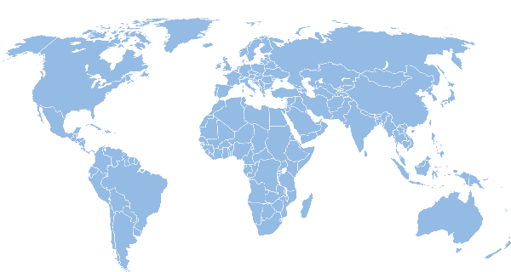
Imagine you are a teacher who wants to work teaching Spanish in an English-speaking country. Where can you go? Name at least 10 different countries and place their names on the world map.

GRAMMAR

Passive voice.

- Complete the following chart with the Passive voice in Present Simple.

 | TO BE (present simple) | VERB (past participle)
I | am | called
You |  | (allow)
He |  | (choose)
She |  | (accuse)
It | is | made
We |  | (admit)
You |  | (teach)
They |  | (write)

- Have a look at the text in the reading section and underline the verbs in passive voice.

- Are you able to guess the structure of the passive voice in Present Continuous? And in Past Simple? Create a chart with each tense in your notebook.

- Present Continuous passive
Look at the pictures and say what is happening. Use these subjects: the car, dinner, a flag, some houses, the seals. Use these verbs: build, feed, raise, repair, serve.

0. The car is being repaired.

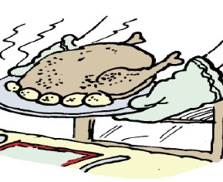
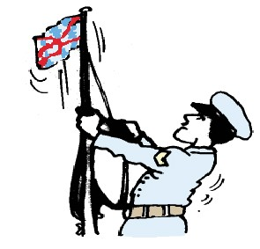
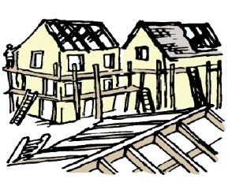
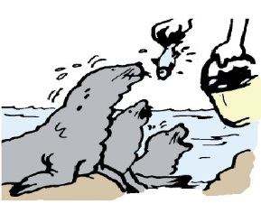

1. . . . . . . . . . . . . . . . . . . . . . . . . . . . . . . . . . . . . . . . . . . . . .
2. . . . . . . . . . . . . . . . . . . . . . . . . . . . . . . . . . . . . . . . . . . . . . .

3. . . . . . . . . . . . . . . . . . . . . . . . . . . . . . . . . . . . . . . . . . . . . .
4. . . . . . . . . . . . . . . . . . . . . . . . . . . . . . . . . . . . . . . . . . . . . . . .

Find more grammar exercises like this in Oxford Practice Grammar Intermediate.

SPEAKING

In pairs, choose a role and read the instructions carefully. You have 3 minutes to work on your own. Then practise the dialogue with your partner.

Student A

Imagine you are the head of a British school. You are going to have a meeting with a teacher who is fed up with his students’ behaviour. You must give him a solution to his problems according to the rules of your school.

Think of actions that students mustn’t do at school and their consequences (smoke, cheat, etc.).

Student B

You are a foreign teacher who is working in a state school in Britain. Your students behave very badly and you are going to meet the head of the school to complain about it. Describe your students’ behaviour and ask him for advice to solve the lack of discipline in your classes.

USEFUL PHRASES

Students are(n’t) allowed to… + Verb (infinitive) It is forbidden to… + Verb (infinitive)

WRITING

Read the following extract from a British newspaper:

The poor state of language-learning in British schools

English children are the only pupils in Europe who are allowed to drop foreign languages completely from their studies after the age of 14.

Write a short composition (80 words) giving ideas to improve British students’ foreign language level.

ANSWER KEY:

READING

A. 1d – 2h – 3c – 4g – 5a – 6b – 7e – 8f

  - head (of school)
  - preserve
  - shortage
  - recruit
  - appal
  - behaviour
  - lay on
  - arrange
    - horrorizar
    - comportamiento
    - escasez
    - director
    - proporcionar
    - organizar, tramitar
    - contratar
    - mantener

B.
- Name four duties of heads of British schools.
  - Supervise the teaching
  - Organize the curriculum
  - Make sure that good order is preserved in the school
  - Fly around the world trying to find teachers to come and teach in your school.

It is hard to find teachers in Britain. Why?
  - Because teachers are often appalled at the behaviour of pupils in Britain schools.

What advantages have foreign teachers got in Britain?
  - The education authorities that employ them lay on special receptions for them and arrange for visa requirements to be relaxed.

VOCABULARY

C.
Canada – The United States – Jamaica – Australia – New Zealand – The United Kingdom of Great Britain (England, Scotland, Wales, Northern Ireland) – Ireland – India – South Africa – The Bahamas – Belize – Madagascar – Nigeria – Pakistan…

READING

D.

 | TO BE (present simple) | VERB (past participle)
I | am | called
You | are | allowed
He | is | chosen
She | is | accused
It | is | made
We | are | admitted
You | are | taught
They | are | written

E.
Is preserved – are recruited – are appalled – are made – to be relaxed

F.

 | TO BE (Pr. continuous) | VERB (past participle)
I | am being | called
You | are being | allowed
He | is being | chosen
She | is being | accused
It | is being | made
We | are being | admitted
You | are being | taught
They | are being | written

 | TO BE (Past simple) | VERB (past participle)
I | was | called
You | were | allowed
He | was | chosen
She | was | accused
It | was | made
We | were | admitted
You | were | taught
They | were | written

G.

- Dinner is being served.

- Some houses are being built.

- The seals are being fed.

- A flag is being raised.

SPEAKING

H.
Students’ own answers.

WRITING

I.
Students’ own answers.

